Tomb of Annihilation

A D&D Adventure

Contents

Contents 1

Additional Characters 3

Rathkran of the Verthisathurgiesh Clan 3

Syndra Silvan 3

Wakanga O’Tamu 3

Eku 4

Xendala 4

Jaheira 5

Montaron 5

Locations and Maps 6

Map of Chult 6

Inventory of the Party 7

The Story So Far 8

7/15/2018 8

Day 1 8

7/22/2018 10

Day 1 (cont.) 10

Day 2 11

Day 3 13

Day 4 13

Day 5 14

Day 6 14

Day 7 14

Day 8 14

Day 9 15

Day 10 16

7/29/2018 17

Day 10 (Cont.) 17

Battle 17

Day 11 18

Day 12 19

Day 13 20

Additional Characters

# Rathkran of the Verthisathurgiesh Clan

I met Rathkran as I walking down the street on my way home. I saw that he was being attacked, so naturally, I jumped in to save him. Once he was safe, I asked him what it was all about. He introduced himself as Rathkran of the Verthisathurgiech Clan. He tells me that he wanted to be a farmer but his parents didn’t agree with him. They grew angry when he ran away to tend to his own farm so they came to attack him. Rathkran said he was grateful for my help and owes me his life. He tells me he will follow me around as a servant.

He has three sheepies that follow him, Eeny, Miny, and Mo. Rathkran loves his sheep. There used to be Meeny, but we don’t talk about Meeny anymore.

# Syndra Silvan

She is an old noble who used to be an adventurer. She has died once on an adventure by taking an arrow to the knee. She has been risen from the dead, and is now affected by the death curse. I know her due to my family owing her a favor. She is seen wearing a mask.

# Wakanga O’Tamu

He is a friend of Syndra Silvan and one of the seven merchant princes.

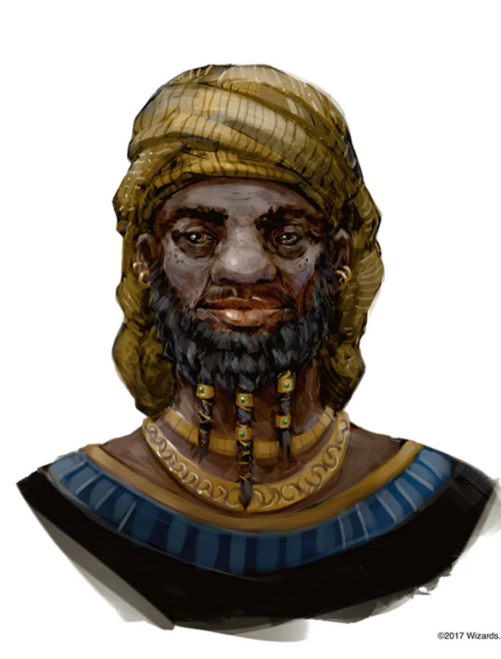

He seems to be very nice.

# Eku

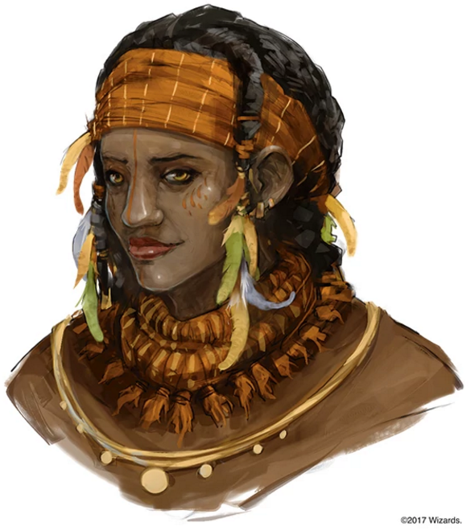

She is a guide. She is going to guide us through the wilderness for a fee of 5 silver per day.

# Xendala

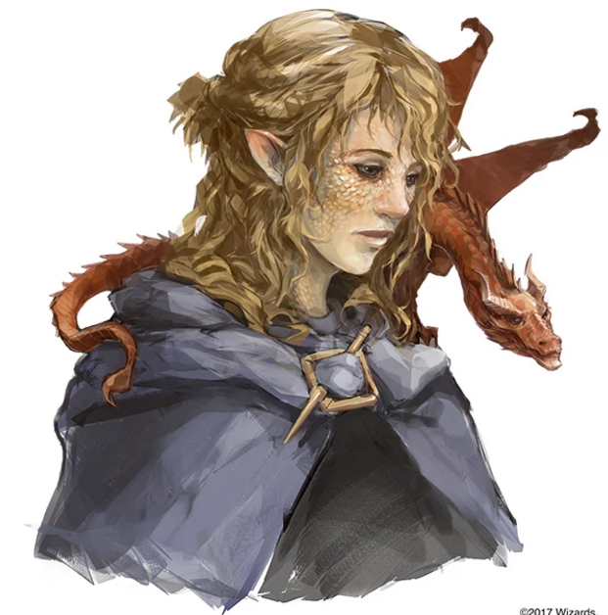

She is looking for her father, whose name is Artus Cimber. She has a pseudodragon friend named Summerwise. We are going to go on a side quest to try and find her father.

# Jaheira

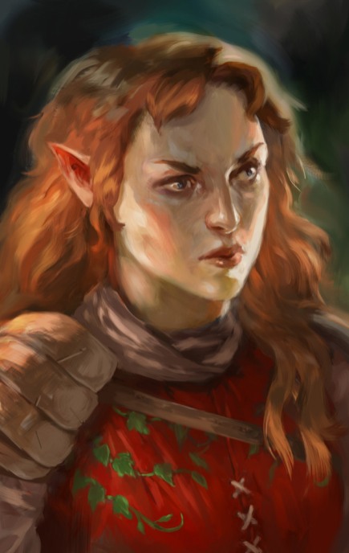

She is an adventurer like us. At this moment, she doesn’t seem like she is very important to us. She was pretty standoffish.

# Montaron

Ilanis seems to know this guy. He is a halfling that is looking to give Ilanis a mission.

Locations and Maps

# Map of Chult

Inventory of the Party

Pouch that has a total of 5 gems. Each gem is worth 10gp

Jug that’s totally not an alchemy jug

The Story So Far

# 7/15/2018

## Day 1

* There is a death curse that is happening
* Syndra Silvan has invited us to her house
  + Learned about Cindiana Bones, who is an archeologist that has explored the underdark
  + There are fancy nummies here
  + Syndra is planning an expedition to Chult
    - It is almost entirely underway
    - Syndra was an adventurer in the past
    - She has died once and was raised from the dead
    - She has been affected by the death curse
    - She wants us to find a cure or cause of the death curse
    - Harpers know that there is a necromantic artifact called the Soul Monger and that it is somewhere in Chult
    - There is not much know about Chult
    - Syndra has a map that she will give us full of all of her knowledge of Chult in exchange for us going on this mission
    - The climate in Chult is not fantastic
    - Syndra will be taking us to Port Nyanzaru to start off
      * Port Nyanzaru is ruled by 7 merchant princes
    - Looks like the flaming fists are trying to claim land there
      * They are the police force of Baulder’s Gate
      * They started out as mercenaries and then they just kind of evolved
      * Syndra doesn’t quite like these guys
    - This expedition is crucial for everyone
    - If we succeed, Syndra will give each of us a magical item
* At around noon, we head over to Port Nyanzaru via a teleportation circle
  + It’s pretty tropical
  + There is a singing mango
  + Syndra is going to introduce us Wakanga O’Tamu
  + There are dinosaurs pulling a cart with a couple Chultians riding on it
* Wakanga has a lovely house that is lit nicely
  + There are harps that seem to be continuously playing in the house
  + There are guards that don’t seem to wear the normal guard attire
    - Since it is very hot here, they don’t have a whole much on
    - They look very exotic
* As we are walking down the street, it appears that people are staring at us, especially Nekka
  + The crowd seems to disperse as we walk past them
  + Even the guards aren’t a fan of us, but they don’t seem to mind Syndra
* Wakanga seems to have a lot of servants
  + He does not have much information about the death curse
  + He does not have the ability to help us get information because we are untrustworthy
  + Syndra suggests that we go to an Inn/Tavern to start looking around
    - She recommends either the Thundering Lizard or Kiya’s House
  + Syndra says there is also a large bizarre that we can shop in
  + She finally gives us the map which Lunette takes
    - Wakanga doesn’t seem to be a fan of the fact that she is giving this map to us
* We have decided to head to Kiya’s House of Repose
  + On our way we pass a colorful palace
  + We pass by the grand Souk, which is a very busy market
    - There are a lot of guards around us
  + People are still shying away from us as we pass through
* We have arrived at the Red Bazaar on our way to Kiya’s House of Repose
* There are people at Kiya’s
  + There is a Bard playing his lovely music
    - She is a drow
  + There is an elven woman sitting by herself at a table just eating
    - She has a quarterstaff sitting next to her
    - She has red hair
  + There is a middle-aged woman also sitting at a table by herself
    - She has feathers in her hair
  + I order a drink for everyone and ask about any interesting news
    - The bartender doesn’t seem to be a friend of Nakka
    - He tells me about a dragon turtle that has been living in the bay of Chult. It wants a lot of treasure, but he isn’t sure about how much
    - Tells us that a lot of people come to drink because their friends and family can’t be risen from the dead
    - Says it started happening about a month ago
    - There are dinosaur races
  + I talked to the human
    - Her name is Eku and she is a guide
    - Her usual rate is 5 silvers per day
    - She is a bit familiar with the wilderness
    - She is not currently working for anyone
    - She wants to know more about it just like we do
  + We started dancing and having a good time
  + We asked the bartender when and where the dinosaur races took place
    - It happens in the streets of the town and it happens it starts in the red bazaar
* We are off to the races!
* There are a bunch of dinosaurs
  + Big Honker
  + Banana Candy
  + Bone Cruncher
  + Grung Stomper
  + Scarback
  + Nasty Boii
  + Jungle Princess
  + Mountain Thunder
* The Race
  + Scarback is on his last race because he’s getting older
  + Nasty Boii is the favorite to win
  + Big Honker has a winning streak
  + We got to pet some dinosaurs
  + Lunette bet 2 gp on Jungle Princess
  + I bet 2 gp on Nasty Boii
* Two-Legged Race
  + Banana Candy
  + Jungle Princess
  + The winner is…… BANANA CANDY
* Unchained Race
  + Nasty Boii
  + Scarback
  + Big Honker
  + The winner is…… SCARBACK AND NASTY BOII
* We go to the red bazaar and buy some stuff

# 7/22/2018

## Day 1 (cont.)

* We finished our shopping and went back to the in
* We cinnamontographers now
* We talked to the bartender, whose name is Bujune
  + I tried to convince him to lower the price, but he didn’t budge
  + I demanded to talk to his manager
    - This doesn’t end well for me
* There’s a smol Kobold named Deekin
  + He seems like a bard in training
* I felt bad for being mean to Bujune, so I got the most expensive thing and paid him double for it
* Nneka gave Deekin one whole gold for him to play a wonderful tune
  + It’s about the Konkey Donks
  + I tipped him 9 silver
  + Ghost gave Deekin another gold piece and gives him a thumb up
  + Lunette pours Deekin a glass of whiskey and gives him 9 silver
* Ghost walked up to the bard and asked about her relationship with Deekin
  + She says she just met him here about a month ago
  + She thought the idea of a kobold being a bard was interesting
  + Deekin came all the way out to Chult just for an adventurous story
* I asked Stella why she’s here
  + Because of this question, she has an existential crisis
  + She tells me that’s she’s here for the same reason as everyone else
  + I asked if she was excited or scared to go on this adventure
  + She tells me that she’s excited
* I danced for a little while longer
* I told Nneka about me and why I am here, which is because my family wants me to be here
* She tells me that someone at her place of employment is related to Syndra
  + Her pseudomother is good friends with Syndra, which caused her to want to want to go and check on Syndra
* We had some *fun* conversation
* After a while, we all went to bed and have lovely dreams

Day 2

* The night was uneventful, with a light rain greeting us in the morning
* Everyone meets downstairs in the morning
* Ghost orders ALL OF ZE BACON
* Nneka eats an egg whole
  + She can do the snek tongue thing
* The door to the inn opens
  + She’s got blonde hair and a blueish cloak
  + We do not recognize this person
  + She looks very frustrated
  + Stella goes up to talk to her
    - She seems like she’s talking to herself
    - She wants help with something
      * Looking for her father
    - She has a thing (It called her Xendala)
      * It’s Mushu
      * His actual name is Summerwise
    - Her father is a very tall, dark haired human
      * His name is Artus Cimber
* Eku comes in after the frustrated lady
  + She notices the bacon
  + She watches Xendala for a while before asking if we are ready to head out
* Deekin was not here. He was probably sleeping off the alcohol
* The red-haired elf lady seems to be an important person
  + She looks standoffish
  + Kinda tall and kinda beefy
  + She looks like she knows what she’s about
  + She is an adventurer like us
  + Her name is Jaheira
  + She says we look pretty strong
* Eku is familiar with a couple of places
  + Nangalore
    - It’s an ancient place/city with a lot of garden
  + She has helped several people go on pilgrimage to Orolunga
    - She starts to tell us about an artifact which we might be able to ask the Naga ghuardian for guidance
  + She tells us a rumor:
    - The Chultians used to worship the God Ubtai. If we happen to find a maze, it’s recommended that we trace it as we might we rewarded
* We agree that the best place to start is going to be
* As we head out of town, Ilanis hears a whisper
  + She follows the whispers
  + She finds a halfling whose name is Montaron
  + He wants to get back at the leader of the flaming fists
  + Looking for proof of the flaming fists working with the pirates
  + If she’s interested, she can meet Montaron at Fort Beluarian
  + She meets up with everyone else
* Eku recommends putting on the bug spray at the moment
  + She says we are going to be traveling through the woods in the southwest
  + She recommends being especially careful around undead
* For the days of travel:
* *We have paid Eku*
* Eku takes us south, pointing out all sorts of beautiful animals, trees and wildlife
* Morning Encounter:
  + There are giant lizards. Eku says they are quite a sight
  + Ilanis very very carefully walks up to the giant lizard to pet them
  + It sniffs her and she pets its snooooooooottttt
* Afternoon Encounter:
  + We are walking along the trail when all of a sudden THERE IS A DEAD BODY! HECK
  + It is an Elf that looks like it has been bit by a poisonous snake
  + Lunette does a small prayer for him
* Night Encounter:
  + We set up our first campfire!
    - We talk about our parents
  + I told everyone about the fact that I love to fish but I have no idea how to swim
  + Lunette was picked up by the Vestani and whenever she had the chance she ran off to explore
  + Lunette does Tarot readings
    - Nneka’s reading: The trader, 8 of gliphs the Bishop upright, Donjon upright, 3 of gliphs the healer reversed, The Temptor reversed
      * She deals with commerce, both legal and illegal
      * There’s a controlling presence in her life that’s working behind the scenes
      * There’s something to do with imprisonment, isolation of banishment
      * There’s illness, disease or something not fantastic to come
      * There may be some magical forces at work in your life, but there may be a deliberate surrender
    - There is a magical force as this is happening. She can’t tell if it’s something that Lunette is doing, but it’s pretty cool. It’s up to Nneka to determine what everything means
    - My reading: The tax collector, 4 of gliphs the shepphard, 3 of swords the soldier reversed, 6 of coins the beggar reversed, 5 of gliphs the druid upright
      * Trustworthy person of power, even in a corrupt environment.
      * I have devoted followers (Ayyyyyy Rathkran) from my past
      * There is an end to a problem with hard work. There’s no quick victory
      * There will be loss and possible ruin in my future
      * There is going to be a balance of nature and a release of emotions
    - I feel the same presence that Nneka did

## Day 3

* *We have paid Eku*
* There was a rough tropical storm, so we spent the day not traveling

## Day 4

* *We have paid Eku*
* There is light rain today, so we will continue traveling. Eku lead us in the southwest direction
* Morning Encounter:
  + Through the mud there is a chittering noise. There is a person-sized lobster
  + 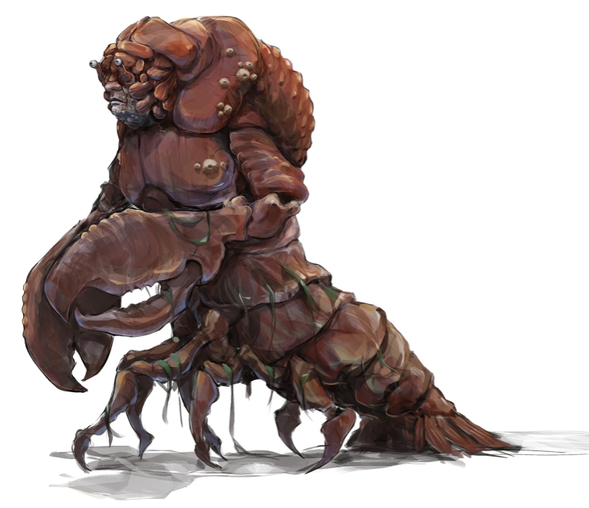
  + Eku tells us that this creature is an Aldani
* Afternoon Encounter:
  + More interesting creatures! This time, we see like, a jungle deer. It yeets past us
  + At first, we think it’s a leopard, but then we see the snek heads
  + 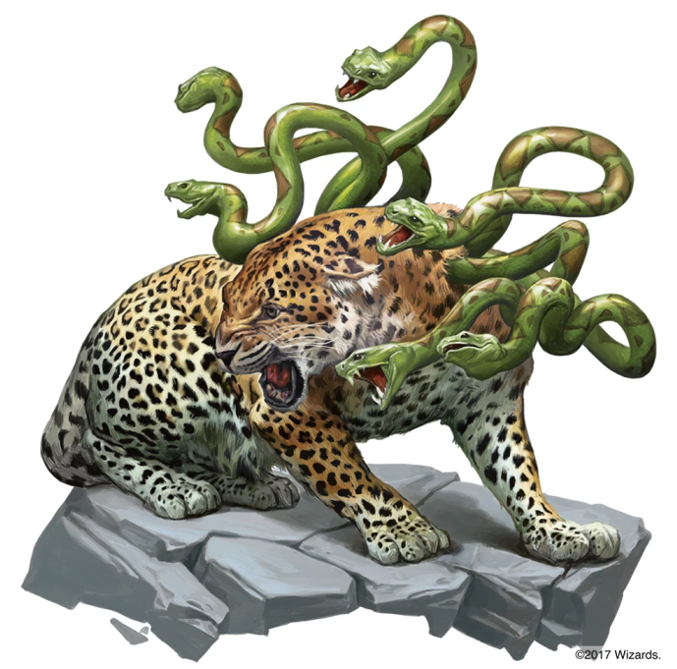
  + We decide to leave it alone
* Night Encounter:
  + We find out that GOHST is from Redwyrm
  + He got recommended for this job. There are benefits for him at home if things are successful for him

## Day 5

* *We have paid Eku*
* There is light rain happening again. Nothing very eventful happens on this day

## Day 6

* *We have paid Eku*
* There is another tropical storm, so we don’t travel

## Day 7

* *We have paid Eku*
* The weather today is a torrential downpour. Some people seem to be starting to run out of food.
* Night Encounter:
  + Eku summons 45 pounds of rations. It can hold us out for about 2-3 days

## Day 8

* *We have paid Eku*
* The weather is once again a torrential downpour once again.
* Morning Encounter:
  + Stella and Lunette feel like the tent seems to be moving around them
  + A hadrosaurs is starting to munch on their tent
  + Lunette handles the hadrosaurs like a fucking champion
  + Nneka disturbs a log. There are 6 horrifying little bat things that fly out of the log
  + 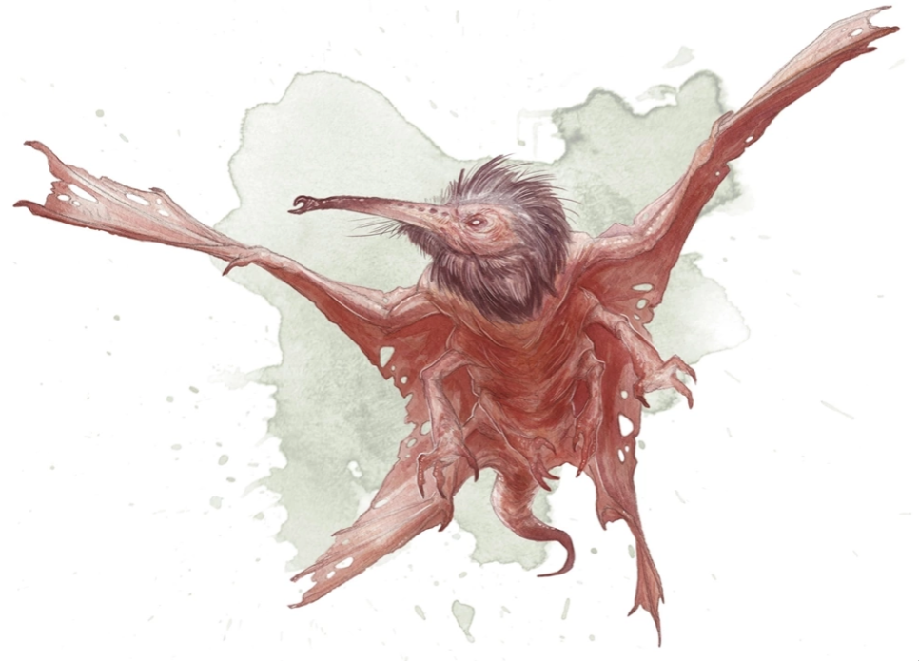
  + Nneka tries to reason with these folks and tries not to scream
  + She does her best to very carefully get off and away from the log
  + Eku does what she can to apologize to the little bat things
    - They are called Stirge
* Nothing of interest happens in the afternoon or the night

## Day 9

* *We have paid Eku*
* It might come as a surprise, but it’s pouring rain again
* Eku tells us there are two places we are going to pass by
* Either Camp Righteous
  + Settlement made by the order of the Gauntlet
  + Would be a place we can probably stay
* The other name of the place is Yellyark
  + This is a place that Eku has passed by but she generally tries to avoid it
  + It’s home to some goblins which is why Eku doesn’t like it
  + She doesn’t know how well the goblins will receive us
* We have decided to go to Camp Righteous
  + Night Encounter:
    - Eku believe we are being followed
    - Stella, Eku and Ilanis are keeping watch
    - 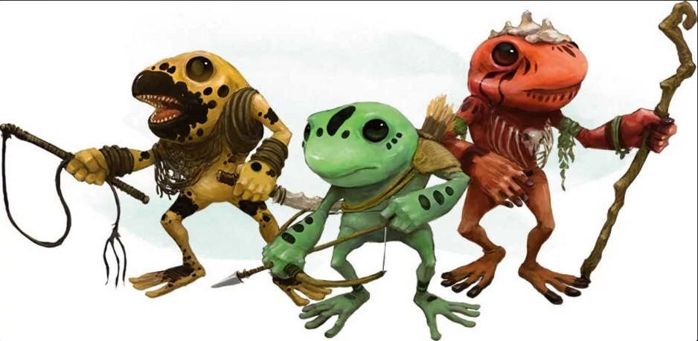They don’t see anything until they are surprised by two frog people who jump out and point their spears
    - Eku is able to reason with the little froggie people and they will let us stay the night

## Day 10

* *We have paid Eku*
* The weather is only a light rain today. Honestly, I don’t think this land knows how to not rain
* We have arrived at Fort Righteous!
* 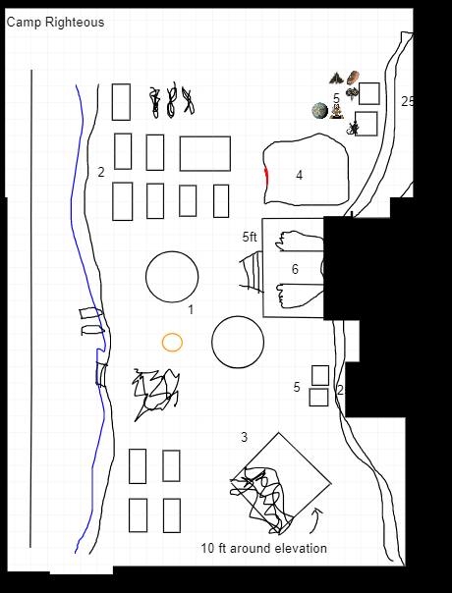
* Everything around Fort Righteous seems to have been ransacked
* Area 2
  + Most of the tents were slashed with claw marks
  + Everything seems to be rotting
  + Eku says it has been a month of two since she was last here
  + There are signs of a struggle here
* Area 5
  + There seem to be two little shacks
  + They smell like super shit
  + There is a dead body here
    - Doesn’t seem to have any stab wounds
    - It is a pit, at least 5ft
    - It died from poop poisoning
    - I have a turd pouch with 5 gems
* Area 1
  + They are abandoned tents
  + Eku tells us the Order of the Gauntlet
  + There are no people inside of here, but there is a single snoot
  + Nneka casts Animal Friendship on it and makes it its friend
  + There are obvious signs of struggle here as well
* Area 3
  + This is a burned-out shrine
  + This is a building and it was definitely on fire at one point
  + There was a pendant in here
* Area 6
  + This is a cave
  + There is a statue here
    - Eku tells us a story about a man who wanted to cross the river. There was a crocodile who spoke to the man asking why he was upset. When the man said he wanted to cross the river, the crocodile offered to bring him across safely in return for a favor. Once they were safely across, the man asked what favor the crocodile wanted. The crocodile wanted to go explore the realm of humans but was afraid of the humans. He wanted to be carried on the man’s back. The man felt as though he had been tricked, but a promise was a promise and he carried the crocodile on his back. The man then swore than the humans and crocodiles would never be friends again.
  + Inside the cave, it seemed a little creepy but otherwise seems like a normal hallway
  + There seems to be some traps here
  + The floor drops out under Stella, but she manages to save herself
    - The gap between us and the other side is 20 ft
    - We come up with a plan to have someone go across with a rope and then hold it to help everyone across
  + There is a second hall that has another set of traps
    - Ghost, despite seeing that we were able to cross with a piggy back, walks through on his own and takes damage
  + There is a puzzle door
    - It’s a checkered pattern
    - I hopped onto Nneka’s shoulders to see if I can see the pattern
    - There were things that were illuminated. I told everyone where to stand
    - Once the pressure plates were set correctly, the lights on the door changed
    - I hopped on Nneka’s back once more and together, we pushed the illuminated buttons
    - The door opened!
  + There was a pillar that had a jug at the top of it
  + It’s totally not an alchemy jug

# 7/29/2018

## Day 10 (Cont.)

* The bushes be rustling
  + It’s goblins

#### ~§~

### Battle

* Eku hits a goblin for 11 damage and kills it
* A goblin hits Nneka for 5 damage
* Stella punches a goblin for a total of 9 damage
* Nneka takes her turn and attempts to hit a goblin but misses. She then uses her bonus action to hide.
* Ghost uses his ice breath to do 9 frost damage to one goblin and 4 to another. The one he did 9 damage to died. After he did that, he action surged to throw a spear at the goblin he did 4 damage to and it does a crit 14 damage to it. Finally, as a bonus action, Ghost uses his off handed weapon to do 5 damage to another goblin.
* Lunette tolls the dead to one of the goblins that took damage but it saved, so he doesn’t take any damage.
* I attempted to use fire bolt on the goblin that Lunette tried to hit, but I missed.
* Eku also attempts to attack the goblin that Lunette and I tried to attack, but she actually succeeded. She did a total of 9 damage and killed the goblin.
* Nneka attempts to take an attack from a bush, but she misses. She goes back to the bush in shame.
* Stella attempts to take out the last goblin, and hits with a total of 5 damage. That 5 damage is enough to kill it.

#### ~§~

* Eku notices that one of the sheepies are missing.
* I’m finna fite
* Nneka and I attempt to look for sheep tracks
  + It appears to have walked off with a bunch of goblins
* Eku knows that the goblin home is in Yellyark

## Day 11

* *We have paid Eku*
* The weather is only a light rain today
* Nothing happens in the morning
* We have made it to Yellyark
* 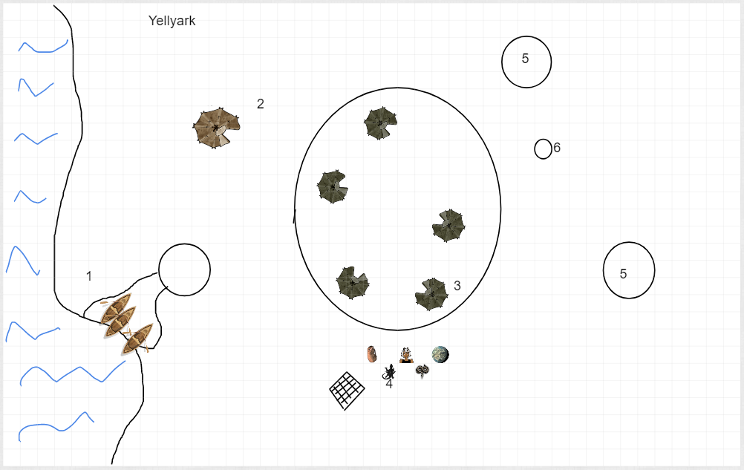
* There is an official looking goblin in the center and there are lesser goblins handing my sheep to him
* 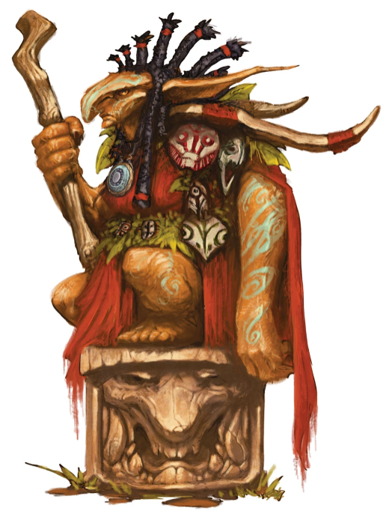
* Ghost is attempting to approach as ready but non-threating as possible
* Nneka is trying to use signs to try to communicate that we want our sheep back
* After a little bit of talking through Eku, we have decided to go and attempt to hunt a dinosaur to try and trade for the sheep back
  + We will have about two days to do this
* Trying to look for tracks but we could not find any
* After going about a mile or two south, I was able to spot a trail of dinosaur footprints
  + Using my knowledge, I could tell that these prints were definitely the guy we were looking to go after
  + All together we were able to follow the tracks of the dinosaur and find it
  + Stella and Ghost were able to take down the tree together
  + Using the tree, we brought the dinosaur to the goblin people
  + They seemed very happy
* Eku mentioned that there are boats that were at Fort Righteous that we should be able to use to travel on water

## Day 12

* *We have paid Eku. I have paid her for a total of two weeks. This means that we won’t have to pay her again until Day 26*
* The weather for today is unsurprisingly a torrential downpour
* I have a strange feeling, like a chill up my spine, but I don’t know the source
* We have made it back to Fort Righteous
* There are boats here that we’re going to use to go in the river
* Syndra’s map is very very valuable
* Night time:
  + Ghost is here because he was volunteered
    - He used to be part of the military
    - He has done a lot of training
    - He used to give a lot of orders
  + We talked a bit about why I’m here
  + Hurray for being not dead
  + Lunette had a skeleton fall on here
    - She was exploring when one fell on her
    - The coolest thing she ever found was a three-sided coin
  + Nneka has a rusty spoon that tastes like meat

## Day 13

* The weather… another torrential downpour. Shocker.
* Eku miraculously remembers the name of the river.
  + It’s the Soshenstar river
* While we are traveling on the river, we find some dead bodies and things
* There is a gate here that Eku doesn’t seem to recognize
* We approach the gate and there is someone on top of it
* After a little bit of back and forth, we determine that this is an Order of the Gauntlet camp
* We are let into the camp and told we should speak to the leader
  + His name is Niles
* 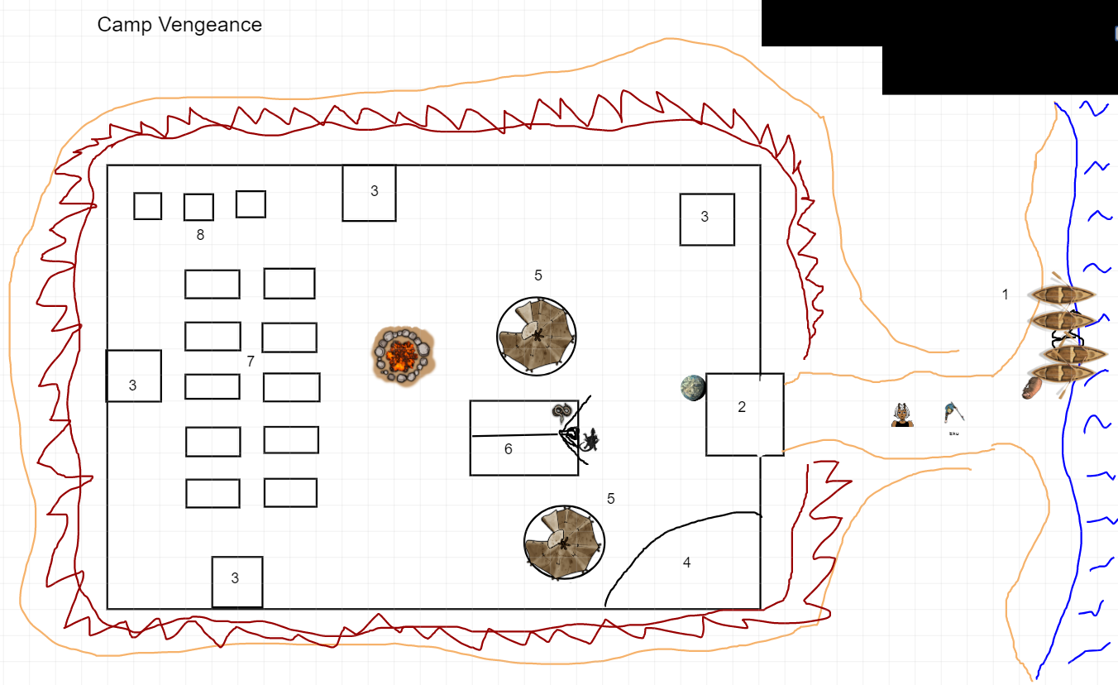
* We are told that this is a camp that was created because Fort Righteous
* People look pretty rough here
* Eku has a friend here that she wants to help (Cleric)
  + Lunette goes and helps Eku, doing cleric things
* Nneka and I have a moment
  + I think it went well :D
* We learn a little more about the death curse
* Plan on investigating by trying to go to the source
* Somehow we negotiate to trade our smaller boats for some bigger ones
  + Lunette points out that we just used their boats to trade them for bigger boats
* Off we go on another adventure

# 8/12/2018

## Day 13 (Cont.)

* We start off… ♪Just around the river bend♪
* We are apparently the “Big swollness”
* We are heading “WeEEeEest”
* He have decided to take the boats and head south
* Nothing happens as we travel ♪Just around the river bend♪
* We have made it to the Aldani Bason
* Eku tells us a tale about the Aldani people as we set up camp for the night
* I asked Neeka if she would teach me how to swim
  + She said yes! (OMG OMG OMG OMG)
  + In return, I want to cook everyone a meal and make Nneka’s extra special
* I look around to try to find something to make good food with
  + I found a dead tree with some shrooms on here
    - These shrooms are not fantastic to eat
    - I tried to pick them up and it was not a very good idea
  + Ghost helped me look for some fish
    - I found one and he caught it for us! Good job, Ghost!
  + I cooked up the food and it was… Not my finest work
* Lunette and I take the first watch
  + There’s a spoopy encounter
  + There appears to be a source
    - Calling the soul monger
  + Uncertain as to who or what is causing it
    - Hypothesis: Litches have velactory
      * Velactories hold the souls of the litch
      * He thinks something like this is what is having an effect on the people around it
      * Basically think there’s a litch involved
    - Heavy concentration in the east
  + Red wizards are divided on some things
    - Thinks curing it can be done by taking the soul monger and studying it
  + Names of the party
    - Dude’s name is Elden
    - Girl’s name is Neera
    - Bigs and Wedge and Lenny are the other not so important lackies
* I woke Nneka and Stella up for their watch
* The rest of the evening passes without an issue

## Day 14

* IT’S A STORM! HOLY SMOKES! WHO. WOULD. HAVE. GUESSED?!?!?!?!?!?!?!!?!?
* We are stuck here for the day
* It looks like Ghost and Elden know each other
* Elden doesn’t look like he didn’t sleep very well
* I added salt to my rations and they tasted better
  + I think my good cooking broke Ilanis, she was too impressed
* Eku and Elden have a stare off
  + Eku nods

## Day 15

* MORE RAIN. I SWEAR, I AM MOVING SOMEWHERE WHERE WATER DOESN’T EVEN EXIST
* Eku is reflecting on Mbala
  + It used to be a village, but it was attacked but supernatural forces
  + They were attacked and Eku was powerless to help them
  + She hopes to visit them on our way back from the Naga
    - We agree to this without fail
* Nighttime
  + I asked Ilanis if she had any special talents
    - She said she has the ability of echo locate
    - She is decent with crafts
    - I heard she’s and absolute THOT
      * This is a lie
    - She really really likes bats
  + Nneka’s favorite animal is a rat
    - I AM GOING TO CATCH HER A RAT!
  + I tried to sneak away to catch a rat
    - I got caught, but I was able to lie
    - I rolled a fucking nat 1 to look for a rat
    - An Aarakocra flies in front of me and offers me a rabbit with a unicorn horn on it
    - 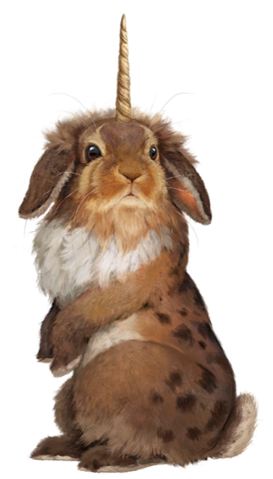 (Almiraj)
    - SHE LIKED IT. OMG OMG OMG SHE LIKED IT! AHHHHHHHH
      * She gave me a peck on the cheek and said it was now her second favorite animal. I am dying, I’m so happy she loves it

## Day 16

* It is only lightly raining right now. Honestly, I will take this over the super massive rain
* Nothing really special happens today

## Day 17

* The weather today is also a light rain
* In the morning, we are approached but 6 Stirge

#### ~§~

### Battle

* One of the Stirges attack Ilanis and attaches to her
* Another Stirge attacks Stella and attaches to her
* Stella pulls the one off of her and kicks it for 4 damage. She then pulls one off of Ilanis and punches it for 4 damage. Both of them are dead
* Two more Stirges attack. One of them attacks Eku and crits her for 9 damage. The other one tried to attack Ilanis but missed
* Eku pulls the stirge off of her and squishes it, doing 14 points of damage to it
* Ilanis started to T-Pose through the fight and so she didn’t get a turn
* Lunette tried to toll the dead on one of them and it worked for a total of 5 damage
* I used magic missile, sending 7 damage to one and 5 points to the last one

#### ~§~

* Nothing really happens in the afternoon
* At night, we are playing cards

## Day 18

* The weather today is also light rain
* In the morning, Eku spots more grung

## Day 19

* The weather today is also light rain
* In the morning, we have been surrounded by light blue mist
  + Eku and Lunette casts bless
  + Everyone but me and Lunette saves
  + Mad Monkey mist
* In the afternoon, nothing happens
* We decided to park the boat
* I feel compelled to touch things constantly
* Poor Lunette is having a panic attack
* I have been tricked into being choked to sleep

## Day 20

* IT’S A TORRENTIAL DOWNPOUR
* This means we aren’t going anywhere